 | 12.1.59 Editors - Geometry Nodes Editor - Header - Add Menu - Geometry Nodegroups - Hair - Write
Table of content
Detailed table of content 1
Add menu - Hair - Write 1
Set Hair Curve Profile 2

Detailed table of content
Detailed table of content
Detailed table of content 1
Add menu - Hair - Write 1
Set Hair Curve Profile 2
Input 2
Geometry 2
Replace Radius 2
Radius 2
Shape 2
Factor Min 2
Factor Max 3
Output 3
Geometry 3

Add menu - Hair - Write

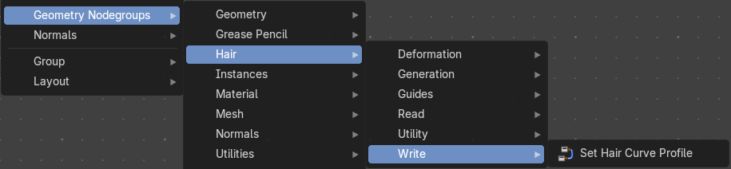
The nodes in this submenu are node groups. They use the regular single nodes under the hood.
It is virtually impossible to document these nodes in detail. So we will just list them.
When you double click the header, then you will enter the first level of the group. When you then press tab, or click again at the header, then you will reach the single nodes.




To leave the group you can use the breadcrumb up left in the header. These breadcrumbs are clickable. Or the Parent Node Tree button up right in the header.

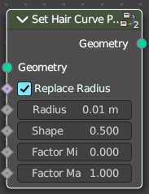
Set Hair Curve Profile
Set the radius attribute of hair curces according to a profile shape.

Input

Geometry
The input geometry.

Replace Radius
Replace the original radius.

Radius
Base radius to be set when replace radius is enabled.

Shape
Shape of the radius along the curve.

Factor Min
Factor of the radius at the minimum.

Factor Max
Factor of the radius at the maximum.

Output

Geometry
The output geometry.

